Pass Task 5 – Shape Drawing

# Related Learning Outcomes

# ULO1 – Explain the OO Principles

This exercise demonstrated object encapsulation teaching me about how you can make features either public or private to only exist within the object. C# has a feature called properties to provide access to data within an object. Making a method static means that you can’t call it through object and since its not part of the object you can’t access the fields.

# ULO2 – Use OO Language and Library

Demonstrated class and constructor declaration, the use of conditional statements (e.g. “if”), and assigning values to parameters. The task examines how fields can be used by an object to remember information. This exercise also introduced the Swingame API, showing me some exclusive methods to perform specific tasks that I had to look up to find information about them.

# ULO3 – Design, Develop and Test using an IDE

The code was developed using Xamarin Studio and the Swingame API to build and run the program, as well as integrated debugging features to step and inspect values.

# ULO4 – Communicate using UML Diagrams

I learned how to interpret a UML class diagram and write the related code. Understanding what part of the UML diagram is for fields, methods and properties.

# ULO5 – Describe Elements of Good OO Design

The exercise demonstrated correct use of C# coding conventions.

# Screenshots

[code running]

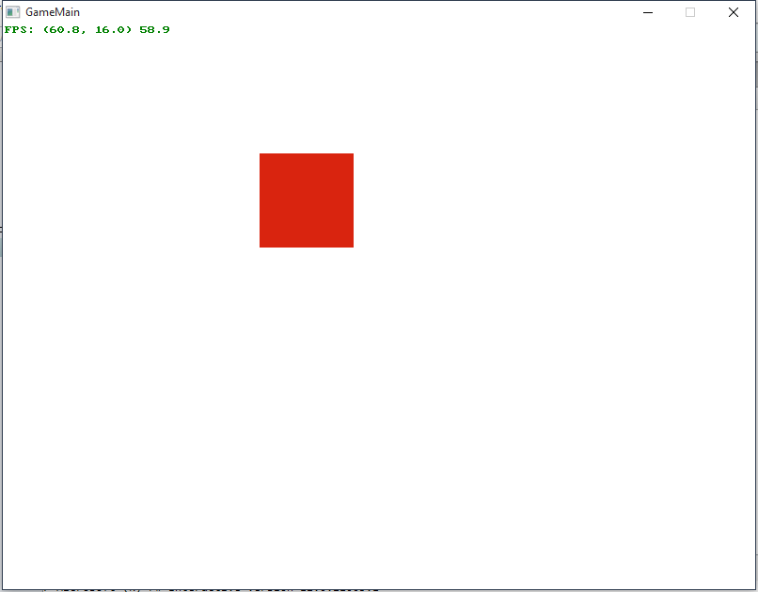

[use of IDE]

